Skylon Park
Employee Travel Survey 2019
Results and Analysis
May 2019
Herefordshire Council Intelligence Unit
Herefordshire Council Energy & Active Travel Team

Contents
Introduction 3
Methodology 3
Key survey Results 4
Conclusions 14

Introduction
Annual Employee Travel Surveys have been carried out at Rotherwas Industrial Estate since 2013. In 2014 the Rotherwas Industrial Estate Area Travel Plan (ATP) was produced as part of the creation of the Hereford Enterprise Zone (Skylon Park). An updated Area Travel Plan was created in 2018. For the purposes of this report the term Skylon Park shall refer to the whole Rotherwas Estate.
The annual travel survey aims to provide an understanding of staff travel patterns and attitudes to commuting to and from the site, and to monitor the effectiveness of the ATP in promoting and supporting sustainable travel options.

Methodology
The travel survey took place between 1st and 30th April 2019 and comprised a combination of online (majority) and paper questionnaires. 392 staff responded to the 2019 survey from 92 different companies and businesses across the Industrial Estate, representing a response rate of 13% based on approximately 3000 employees. A link to the online survey questionnaire was sent by Herefordshire Council’s Travel Team to all employers with premises located on Skylon Park (219 businesses). Printed copies were also available via the employer on request. In addition, the survey questionnaire was published on Herefordshire Council’s website, where a download and print option was also available. All staff working for an employer with premises located on Skylon Park were eligible to take part in the survey and a prize draw with a £100 prize was offered as an incentive to participate.
Note: All analysis is based on the number of respondents to the question, not total survey respondents, as some questions were not relevant to all respondents.

Key survey Results

DISTANCE EMPLOYEES TRAVEL TO WORK
Fig.1 – Approximately how far do you travel to work (one way)?
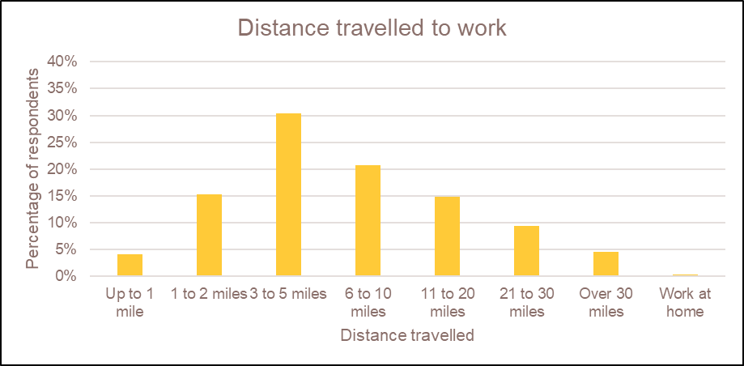
The survey results showed that 19% of employees live within 2 miles of Skylon Park and 49% within 5 miles. These journeys have potential to be walking (within 2 miles) or cycling journeys (within 5 miles) respectively. These results are similar to the 2018 survey with 18% of employees living within 2 miles and 51% within 5 miles.

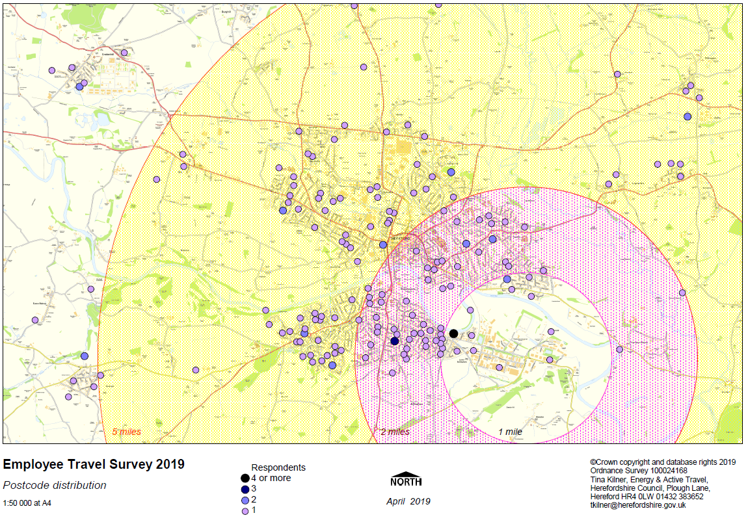
Post code Employee distribution
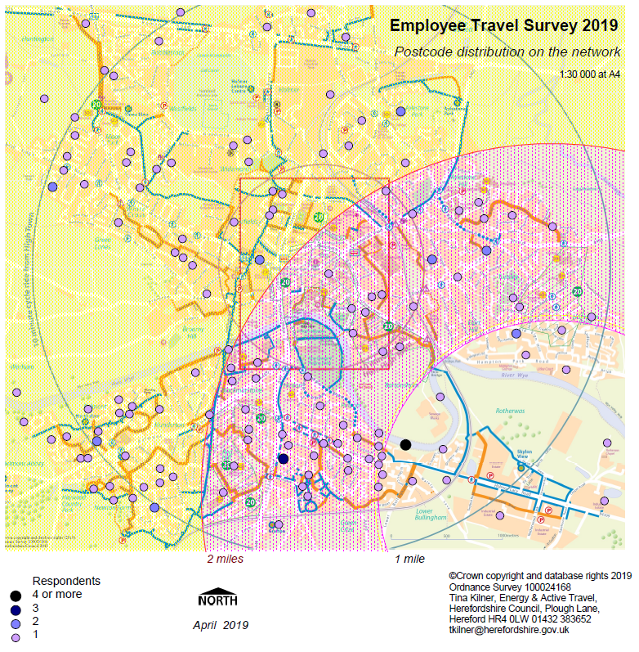
Fig.2 (Above) – Postcode distribution of Skylon Park employees
334 respondents provided their postcode. The dots are not exact home locations but centre of postcodes. The circles on the map showing distance from Skylon Park may not give an accurate indication of length of commuter journey, due to the need to travel across the river.

Fig.3 (Left) – Postcode distribution in relation to key walking and cycling routes to Skylon Park
Map showing the key walking and cycling routes (Orange and blue lines) in relation to employee postcode data.

Main Mode of travel to work
Fig.3 - How do you usually travel to work for the main part of your journey
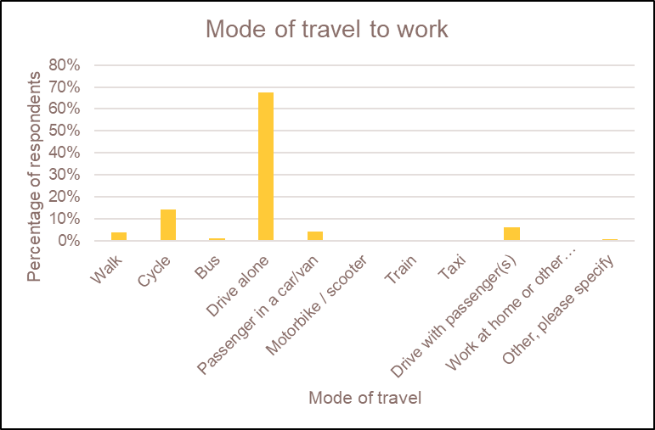
The survey results showed that 68% of employees travelled alone by car (72% in 2018). A further 10% shared a car either as a passenger or the driver (9% in 2018), 14% cycle (12% in 2018) and 1% take the bus to work (2% in 2018).
As there is variation in which businesses distribute the survey to their employees each year, this could affect the type of journeys that are reported. For example, office based businesses are likely to have a different journey profile to businesses that require their employees to use a van for work. These variations will be viewed as part of longer term trends.

Fig.4 - Responses to this question by survey year
Mode of travel* | 2013 | 2014 | 2015 | 2017 | 2018 | 2019
Car alone | 61.0 | 70.0 | 68.0 | 69.0 | 72.0 | 68.0
Car share (driver or passenger) | 15.0 | 12.0 | 12.0 | 12.0 | 9.0 | 10.0
Bus | 2.0 | 1.5 | 2.0 | 1.0 | 2.0 | 1.0
Train | 0.5 | 0.0 | 1.0 | 0.0 | 0.0 | 0.0
Walk | 5.0 | 4.0 | 2.0 | 2.0 | 3.0 | 4.0
Cycle | 14.0 | 12.0 | 11.0 | 14.0 | 12.0 | 14.0
Motorcycle/moped/scooter | 2.0 | 1.0 | 1.0 | 0.0 | 1.0 | 0.0
Taxi | 0.0 | 0.0 | 0.0 | 0.0 | 0.0 | 0.0
Other |  |  | 3.5 | 1.0 | 1.0 | 1.0
Total responses | 99.5 | 100.5 | 100.5 | 99.0 | 100.0 | 98.0

* 2013-2017 Figures are from the 2017 Hereford Enterprise Zone Employee Annual Travel Survey Analysis Report.
** Some percentages for previous years do not total 100 per cent, presumably due to rounding.
# 2018 and 2019 percentage has been derived by amalgamating “passenger in a car/van” and “drive with passenger/s”, in previous years the question wording was different and the figure derived by amalgamating other options.
Note: The wording of this question has not been consistent over the period, which could affect how respondents answered.

Alternative mode of travel to work

Fig.5 - Do you also occasionally travel to work by another method?

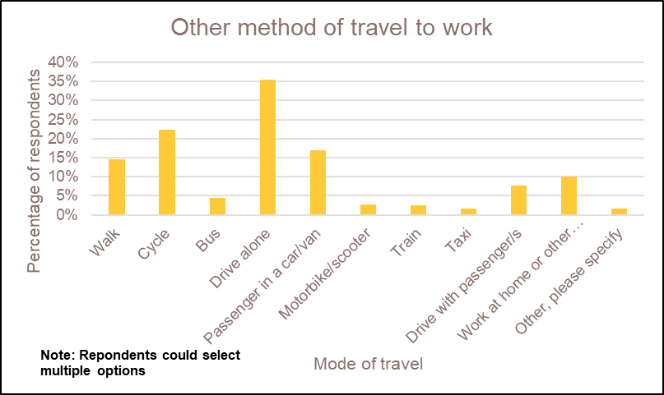

 | No. of respondents | Percentage
Walk | 42 | 14%
Cycle | 65 | 22%
Bus | 13 | 4%
Drive alone | 103 | 36%
Passenger in a car/van | 49 | 17%
Motorbike/scooter | 8 | 3%
Train | 7 | 2%
Taxi | 5 | 2%
Drive with passenger/s | 22 | 8%
Work at home or other location (not Rotherwas) | 29 | 10%
Other, please specify | 5 | 2%
Total responses | 290 | 120%

*Note: percentages do not total 100 per cent because the respondent could select more than one option.

Many employees also occasionally cycle, walk or car-share to work (Fig.5). These results are similar to 2018 but with a higher percentage of occasional cyclists (22% in 2019 compared with 18% in 2018) but a lower number of occasional walkers (14% compared to 19%). The comments show that this seems to vary widely depending on personal circumstances and the weather, with many also saying they do not travel by another method. Alternative modes give an indication that these methods of travel have potential to be used more regularly.

Work arrival times

Fig.6 - What time of day do you normally arrive at work?

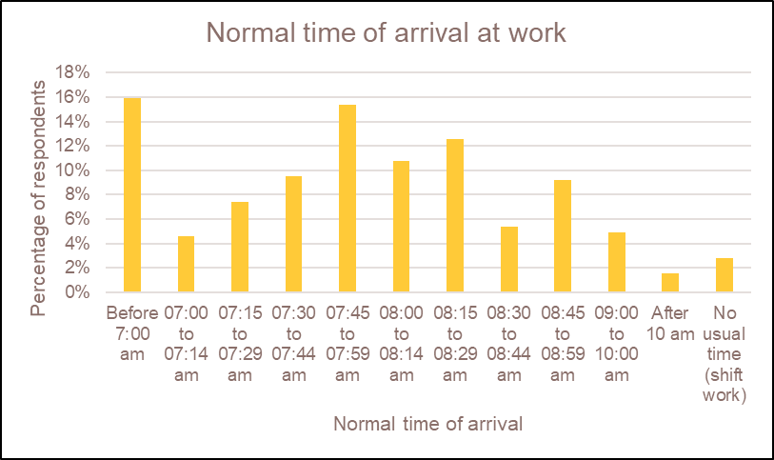

48% of employees start work between 7:30-8:30, 16% before 7am and only 7% starting after 9am.

Work finish times

Fig.7 - What time of day do you normally leave work?

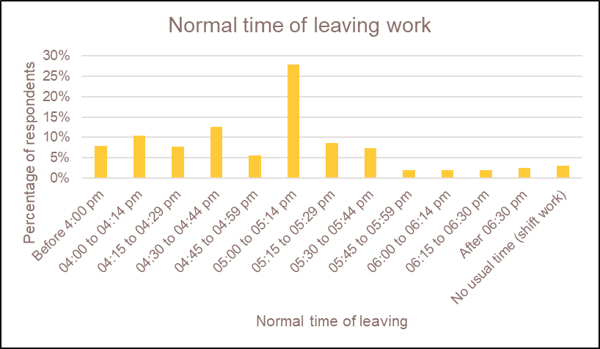

The most common time that employees leave work is between 5:00 – 5:14pm (28%). 32% of people leave work between 4-4:59pm and 16% leave between 5:15-5:44pm.

Changes to encourage Walking and Cycling to work

Fig.8 - Which of the following changes would encourage you to walk or cycle to work?

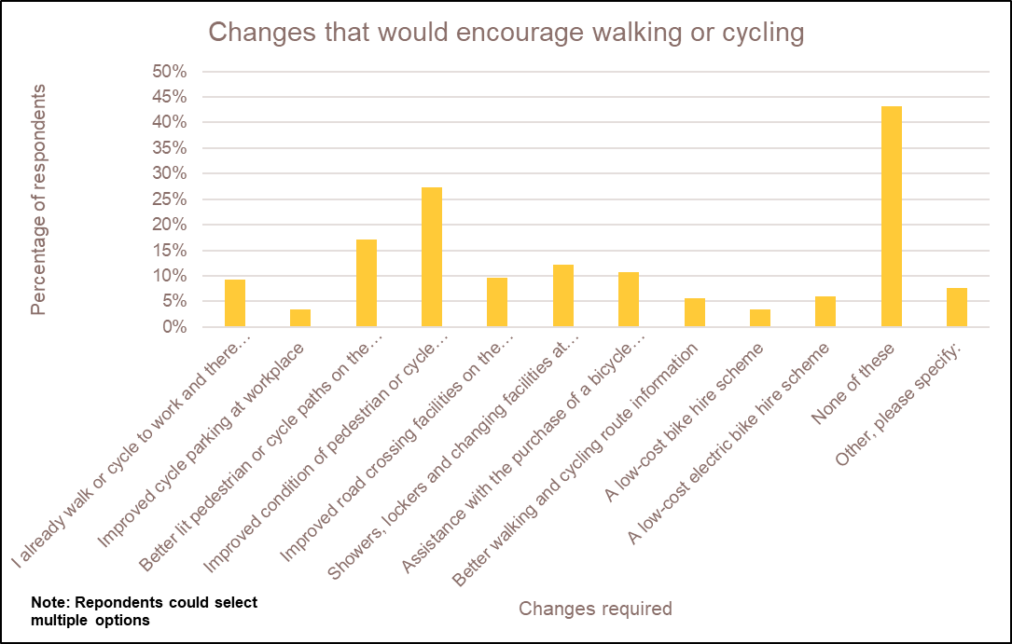

*Note: percentages do not total 100 per cent because the respondent could select more than one option. Of the 265 respondents who selected “drive alone” in response in Fig.2, 142 (54%) selected “none of these” in response to this question.

Improving the condition of pedestrian walkways and cycle paths to the estate would encourage the most people to cycle and walk to work (27%) (same as 2018), followed by better lit paths (17%) (15% in 2018), Showers, lockers and changing facilities at workplace (12%) (10% in 2018) and assistance with the purchase of a bicycle (11%) (13% in 2018).

43% of respondents said that none of the suggested changes would encourage them to walk or cycle with many commenting that the distance is too far to walk or cycle from home, and others mentioning that they need a car to do the school/nursery run before work. Others commented that they would only cycle if the weather was better and others wanting safer cycle lanes/paths. A few also mentioned that better parking on the north side of the Greenway Bridge would be useful, so they can then part drive, part walk/cycle to the estate.

Changes to encourage Bus use

Fig.9 - Which of the following would encourage you to travel by, or continue to travel by, bus?
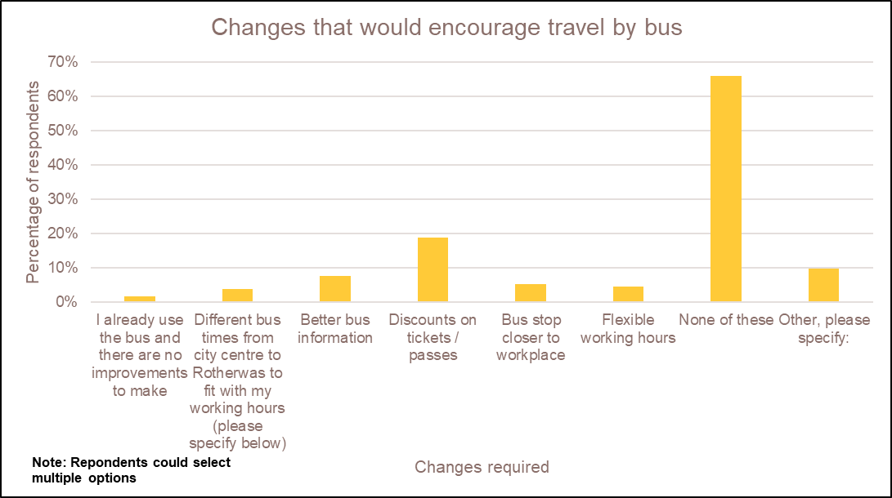
*Note: percentages do not total 100 per cent because the respondent could select more than one option. Of the 265 respondents who selected “drive alone” in relation to Fig.2, 178 (67%) selected “none of these” in response to this question.

The most popular measures were discounts on tickets (19%) (15% in 2018), better bus information (8%) (9% in 2018) and bus stop closer to the workplace (5%) (Same in 2018). A large proportion (66%) however stated that none of the suggested changes would encourage bus use. People further commented on the expensive price of bus tickets compared to driving, the inconvenience in time and money of having to get connecting buses and no existence or limited service of a bus or route from their home.

Changes to encourage Car-sharing

Fig.10 - Which of the following would encourage you to car share?

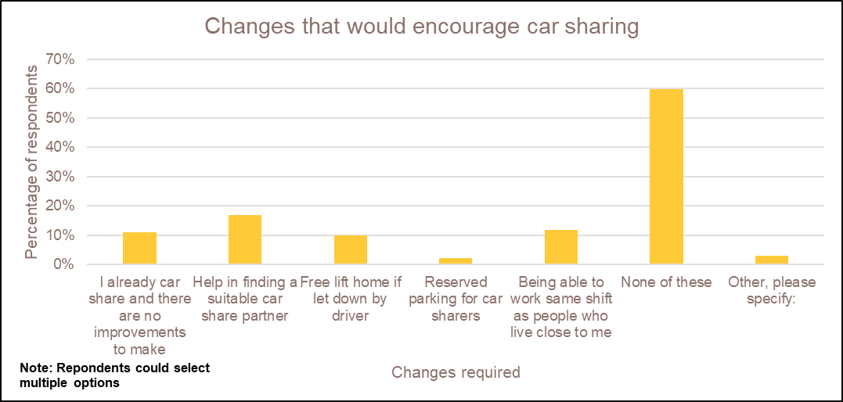

*Note: percentages do not total 100 per cent because the respondent could select more than one option.

The most popular measures included help in finding a suitable car-share partner (17%) (19% in 2018), being able to work the same shift pattern as others who live close by (12%) (Same in 2018), and a free lift home if let down by other drivers (10%) (7% in 2018). A further 11% already car-share and said there was no improvements to be made (9% in 2018). Further common comments included not being able to car-share due to working part time, working varied hours or having different shift patterns to others. Others commented that they do not live by any work colleagues or know of anyone who lives nearby to car-share with. A few also commented that they would only be happy to car share with colleagues rather than strangers. 60% said none of the suggested ideas would encourage them.

Reasons for Car travel

Fig.11 - If you travel to work by car, what are your main reasons for doing so?

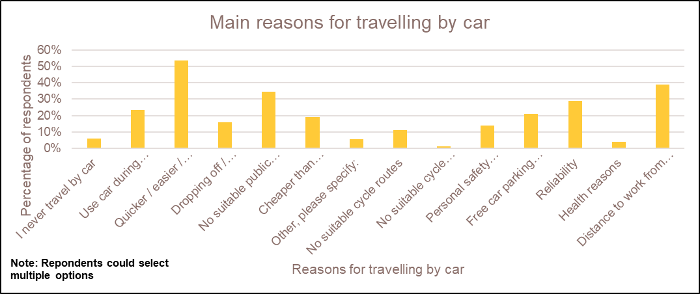

*Note: Percentages do not total 100 per cent because the respondent could select more than one option.

The main reasons for car travel included quicker, easier and more convenient (54%) (Same in 2018), distance to work from home (38%) (39% in 2018) and no suitable public transport services from where someone lives (37%) (35% in 2018). There were additional comments around people using a car due to weather conditions and some saying they only use a car when the weather conditions are poor. Others commented how they need the car for work purposes or an activity after work, citing the flexibility and reliability of car use.

Further comments on travel to and from work to Skylon Park
A significant proportion of employees commented on the traffic situation around town getting to/from work, with congestion adding time to their route. In addition, potholes and poor road conditions were also a concern for both car drivers and cyclists. A few also mentioned the need to drop their children off at school before work, which prevented them from cycling.
Similar comments made by a number of respondents included:
- Bus and train fares being too high to use them.
- Support for the proposed Hereford bypass / ring road.
- Better cycle route needed under the Holme Lacy bridge required so cyclists do not have to dismount and/or use the road instead.
- Comments around dangerous driving of cars and HGVs drivers around cyclists
- Some cyclists not using the designated cycle paths on the estate instead of the main road.
- Better transport connections to/from Gloucester e.g. rail route / dual carriage way.

Conclusions
The results from this survey have informed the creation of a new Action Plan 2019-21 which is linked to the overarching Skylon Park Area Travel Plan 2018-21. These can be found on the Skylon Park website: www.skylonpark.co.uk/about-the-zone/travel-planning.
The Area Travel Plan and Action Plan will be implemented by the Skylon Park team and Area Travel Plan Co-ordinators, in partnership with businesses and other Herefordshire Council departments.
Additional monitoring is being carried out and regularly reviewed, including pedestrian and cyclist counts at key locations.

